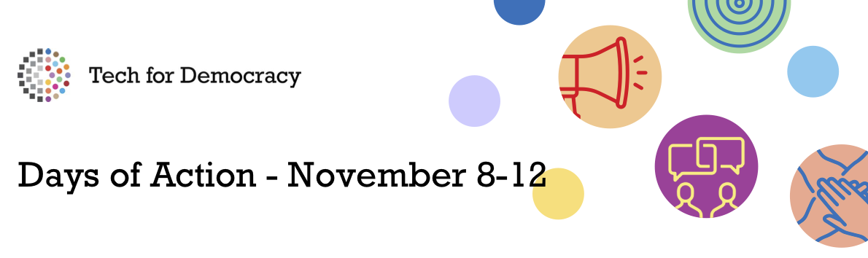
Summary of session on:
“National Human Rights Institutions as digital rights watchdog”
12 November 2021 from 11:00-12:30 UTC+1
Organisers: Danish Institute for Human Rights

Session description: National Human Rights Institutions (NHRIs) are uniquely placed in the nexus between public and private actors and civil society and can work to ensure alignment towards better human rights protection and promotion in the digital age.
The session looked at how the NHRI mandate areas are challenged by technology and what opportunities technology provides in fulfilling these with a view to establishing an alliance of NHRIs who wants to increase their engagement with the digital rights agenda. The participants also explored the particular role that NHRIs can play in each of the NHRI mandate areas, such as complaints-handling, monitoring & reporting, awareness-raising and advice to the government.

Speakers:
- Eva Grambye, Danish Institute for Human Rights
- Maureen Mghambi Mwadime, Kenya National Commission on Human Rights
- Fadlah Adams, South Africa Human Rights Commission
- Ashnah Kalemera, CIPESA - Collaboration on International ICT Policy for East and Southern Africa

Moderators:
- Line Gamrath Rasmussen/Jane Klementieva, Danish Institute for Human Rights

Summary of discussions:
- As a NHRI community, we need institutions that show leadership and pave the way towards stronger and more visible execution of our mandates within the technology realm

- NRHIs should focus on:
  - Internally:
    - Build competences and capacities, incl. through closer cooperation and exchange with tech-community/experts, expert reference groups, peers at global level etc.
    - Develop concepts and methods for HRBA to coding, robotics and other tech-related areas
    - Improve own IT systems and make them more efficient for execution of mandates
  - Externally:
    - Conduct systematic monitoring and reporting on tech and human rights issues, or at least document human rights violations by or within the tech sector in our countries
    - Develop frameworks, recommendations etc. to protect different groups of citizens from violations of their human rights by or within the tech sector
    - Ensure visibility of own mandate and awareness of stakeholders on what NHRIs can and should do in this area
    - Getting a seat at the table: take part were possible and try to influence decision-making and regulatory frameworks and monitor gaps
    - Update complaints-handling to embrace digital human rights violations and ensure access for human rights defenders, vulnerable groups etc.
    - Curriculum development and other HRE activities to ensure that schools and universities both incorporate both tech-relevant and human rights skills into their curricular
    - Develop benchmarks towards which progress and performance of different actors can be measured
    - Definition of the human rights and tech landscape in our countries; incl. research and analyses, as well as clarifications of terms, standards, principles etc. to reduce grey areas
    - Capacity build national actors on tech and human rights
    - Advise governments on human rights compliance when it comes to use of technology and support efforts to ensure meaningful connectivity
    - Raise awareness of rights-holders

